Chapter-
Abdul in the garden
- Mention the functions of roots.
Ans:

2.Roots are mainly two types – tap root and fibrous root. Mention the difference between them with examples.
Ans:
Tap root | Fibrous root
a.These roots penetrate deep inside the soil. | a.These roots are shallow and do not penetrate deep inside the soil.
b. They have long main root. | b. They do not contain main root.
c. Provides strong anchorage. | c. Provides moderate anchorage.
Ex- carrot, beetroot, radish etc. | Ex- rice, wheat ,grass etc.
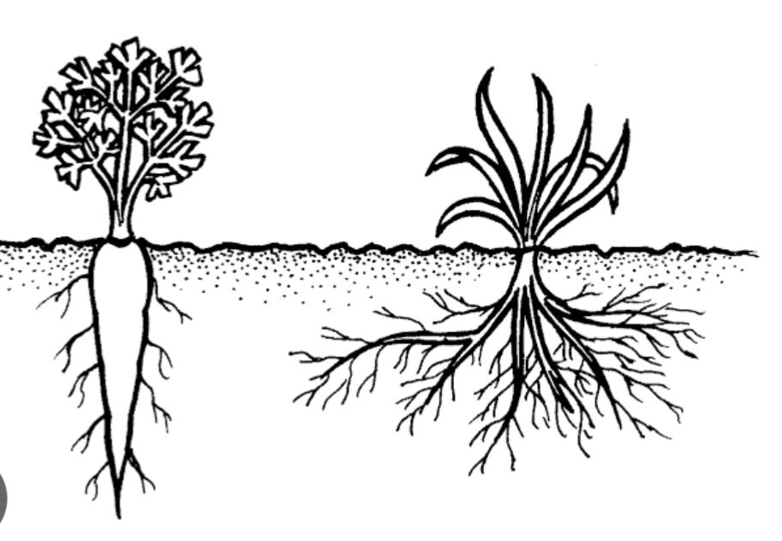
3.In a crop field there are many unwanted plants growing along with crop plants.
(i) What are they called?
(ii) Give two examples.
Ans:

4. Explain the process of weeding .
Ans: The process of removing unwanted plants , called weeds from ,a garden or a crop field so that plants that you want to grow have enough space ,water ,sunlight and food to grow properly.

5. The big neem tree or mango tree doesn’t easily get uprooted during a heavy rainfall or storm . Give reason.
Ans: The big neem tree or mango tree doesn’t easily get uprooted because of their extensive ,deep taproot system that anchor them firmly in the soil.
6. Explain the term soil erosion.
Ans: Soil erosion is the removal of the top soil due to the force of wind or water.
7. Planting lo can prevent soil erosion.How?
Ans: Top soil is the most fertile part of the soil for growing healthy crops or trees. Roots hold the top soil and prevent it from getting carried away by strong wind or water.
8. Some trees such as banyan tree develop aerial roots. Why?
Ans: Huge trees like -banyan trees develop aerial roots as they grow old. These are extra roots that grow down from the branches of the tree. These are also known as prop roots as they provide extra support to the huge, growing trees .
9. There is a law against cutting trees.
(i) What is the law called?
(ii) What will happen if one will not abide by this law?
Ans i ) The law against cutting trees is Indin Forest Act 1927.
(ii) According to this act if someone will cut the tree planted by government without taking any permission from the government ,one can get imprisonment for many years and also be penalized .

